
General Sir John Kotelawala Defense University, Sri Lanka Faculty Of Engineering

ET3112 Assignment 02

Student Name : R.M.S.D.Rathnayaka
Registration Number : D/ENG/24/0153/EE
Instructed By : Dr. Sampath Perera
Stream/Intake : Intake 41
Module Code/Name : ET3112-Image Processing and Machine Vision
Date Of Submission : 20.03.2026
Github Link :

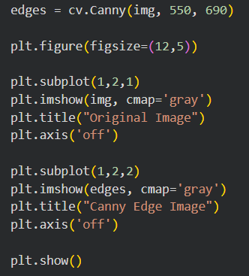
1)

indices = np.where(edges != 0)
x = indices[1]
y = indices[0]

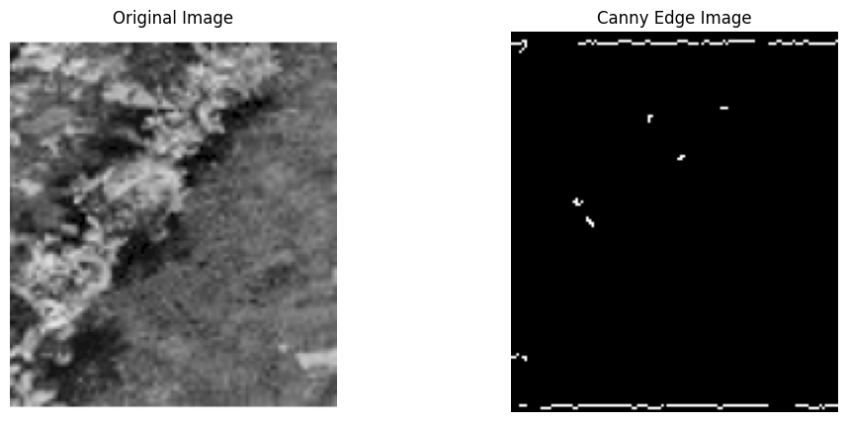

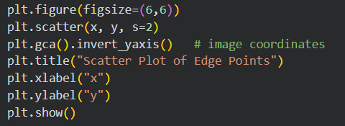
2)

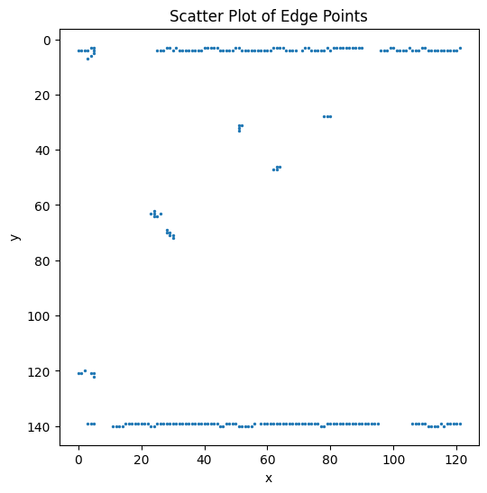

3)
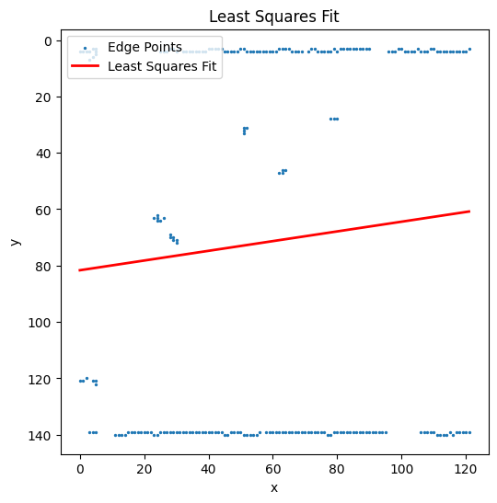
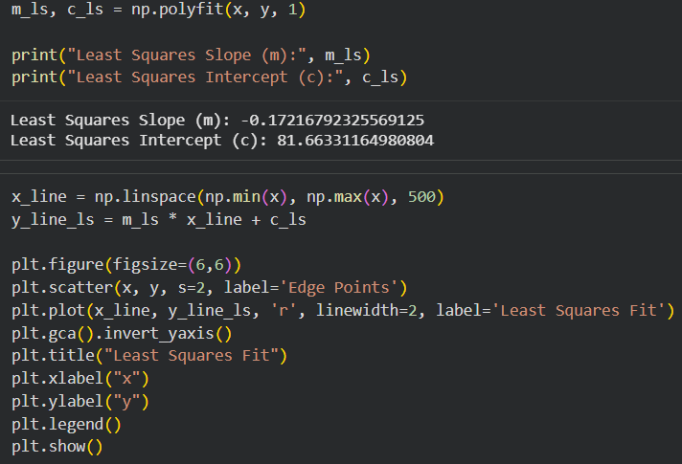
4)
Calculate angle
θ=tan⁻¹(m)
θ=tan⁻¹(0.1721679)
θ= 9.78∘
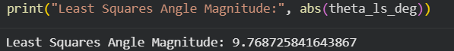
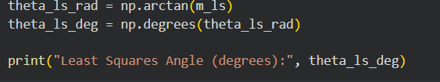
5)

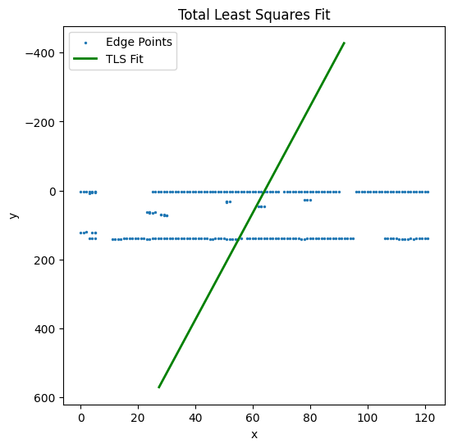
No, the estimation is not correct. The least-squares-fit method is sensitive to noise and outliers in the edge image. The Canny edge detector extracts not only the main crop boundary but also many unwanted edge points from background texture and vegetation. Since least squares minimizes the sum of squared vertical errors, these irrelevant points influence the fitted line strongly and pull it away from the true crop boundary. As a result, the estimated angle becomes inaccurate.
6)
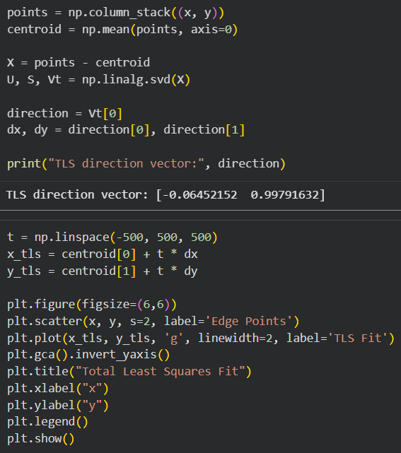

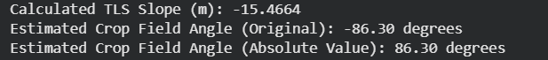
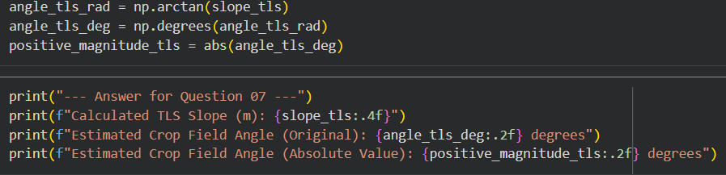
7)

8)
No, the total least-squares estimation is still not correct. Although TLS is better than ordinary least squares because it minimizes the perpendicular distance from the points to the fitted line, it still uses all detected edge points in the calculation. The edge image contains many noisy points and unwanted background edges that do not belong to the actual crop boundary. These outliers influence the fitted line and make the estimated angle inaccurate. This is why the TLS result became very large and close to a vertical line

A better algorithm for this scenario is the Random Sample Consensus (RANSAC) method. RANSAC is a robust algorithm used to estimate a mathematical model from a dataset that contains a large number of outliers. Instead of using all data points, it randomly selects a small subset of points to estimate a model and then checks how many other points agree with that model (inliers). Points that do not fit are ignored as outliers. This process is repeated multiple times, and the model with the highest number of inliers is selected as the best fit. Therefore, RANSAC is more suitable for this scenario because it effectively removes the influence of noisy edge points and provides a more accurate estimation of the crop field boundary.
9)

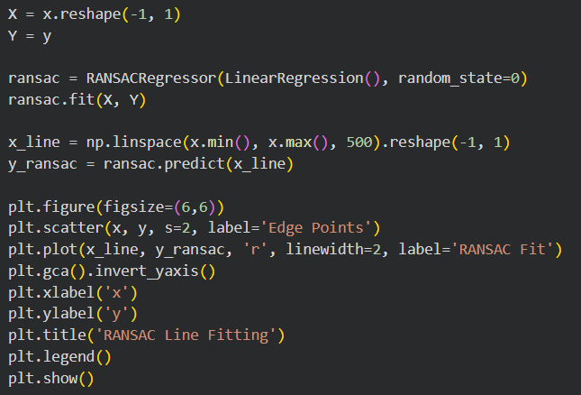
10)

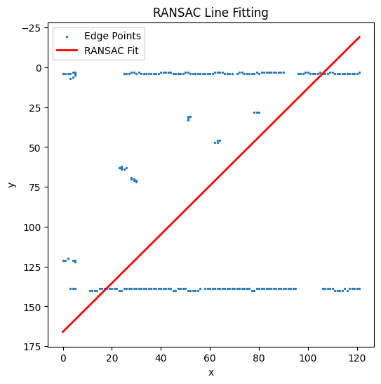

11)
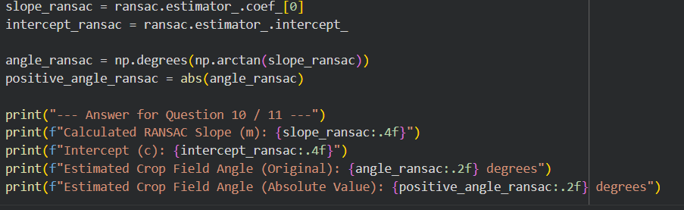
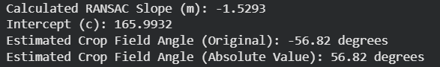
12)

